**Phase 5**

**PROJECT DOCUMENTATION & SUBMISSION**

|  |  |
| --- | --- |
| **Date** | **31-10-2023** |
| **Team ID** | **718** |
| **Project Name** | **Website traffic analysis** |

|  |  |  |
| --- | --- | --- |
| **S.NO** | **TABLE OF CONTENTS** | **PG.NO** |
| **1** | **Introduction** | **1** |
| **2** | **Problem Statement** | **2** |
| **3** | **Problem Identified** | **3** |
| **4** | **Data Collection Process** | **3** |
| **5** | **Analysis Objectives** | **4** |
| **6** | **Literature Survey** | **6** |
| **7** | **Design thinking** | **9** |
| **8** | **Technology architecture** | **11** |
| **9** | **Modules description** | **13** |
| **10** | **Algorithm and technology used** | **17** |
| **11** | **Python code integration** | **19** |
| **12** | **Data visualization using IBM Cognos** | **22** |
| **13** | **How Insights Improve User Experience** | **30** |
| **14** | **Conclusion** | **32** |

**1.INTRODUCTION:**

Our Project represents a comprehensive effort to gain valuable insights into user behaviour, trends, and engagement on a website. In an era where digital presence is of paramount importance, understanding how visitors interact with a website is crucial. This project for causes on harnessing data-driven methodologies to provide website owners with actionable insights aimed at enhancing the overall user experience.

Website traffic analysis is not merely about monitoring visitor counts; it's about unlocking the hidden stories within the data. By leveraging a combination of data analysis tools and techniques, including time series analysis, machine learning, and data visualization, we aim to uncover patterns and trends that go beyond the surface metrics. These insights will empower website owners to make informed decisions and optimize their online platforms. Our project encompasses various phases, from data collection and preprocessing to in-depth analysis and forecasting. The integration of advanced tools such as Prophet, Statsmodels, and machine learning models allows us to dig deep into the data and provide a holistic view of website traffic. Furthermore, we've incorporated A/B testing and user segmentation to ensure a user-centric approach, making recommendations that not only boost traffic but also enhance user engagement.

In this project, we explore how design thinking, technology architecture, and the seamless integration of modules work together to address real-world challenges faced by website owners. Our document will delve into the intricacies of each phase, detailing the algorithms and technologies used, and how insights are translated into actionable strategies. This project's ultimate goal is to provide a blueprint for enhancing user experience, guiding website owners towards a more engaging and data-informed digital environment.

**2.PROBLEM STATEMENT:**

Objective: The objective of this project is to analyse website traffic data, derive actionable insights, and provide recommendations to enhance the user experience. We will achieve this through a multi-phased approach,combining data analysis, time series forecasting, machine learning, and data visualization techniques.

**3.PROBLEM IDENTIFIED:**

we identified a significant problem that revolved around the decline in the percentage of returning visits, particularly on specific days of the week. This decrease in user engagement and loyalty raised concerns about the website's ability to retain its user base. Additionally, our analysis revealed irregular patterns in page loads, indicating potential issues with user experience. These problems collectively pointed to the need for focused content optimization and user engagement strategies to enhance the website's "stickiness" and encourage returning visits. Addressing these issues was crucial in order to improve the overall user experience and maintain user retention on the website.

**4.DATA COLLECTION PROCESS:**

Our dataset contains 5 years of daily time series data for several measures of traffic on a statistical forecasting teaching notes website whose alias is statforecasting.com. The variables have complex seasonality that is keyed to the day of the week and to the academic calendar. The patterns you you see here are similar in principle to what you would see in other daily data with day-of-week and time-of-year effects. Some good exercises are to develop a 1-day-ahead forecasting model, a 7-day ahead forecasting model, and an entire-next-week forecasting model (next 7 days) for unique visitors.

The variables are daily counts of page loads, unique visitors, first-time visitors, and returning visitors to an academic teaching notes website. There are 2167 rows of data spanning the date range from September 14, 2014, to August 19, 2020. A visit is defined as a stream of hits on one or more pages on the site on a given day by the same user, as identified by IP address. Multiple individuals with a shared IP address (e.g., in a computer lab) are considered as a single user, so real users may be undercounted to some extent.A visit is classified as "unique" if a hit from the same IP address has not come within the last 6 hours. Returning visitors are identified by cookies if those are accepted. All others are classified as first-time visitors, so the count of unique visitors is the sum of the counts of returning and first-time visitors by definition. The data was collected through a traffic monitoring service known as StatCounter.

We sourced our data from a dataset named "daily-website-visitors.csv." This dataset included pivotal fields such as "Date," "Page Loads," "Unique Visits," "First-Time Visits," and "Returning Visits." Through rigorous data cleaning, we ensured the dataset was suitable for analysis. Additionally, Python code was seamlessly integrated into IBM Cognos for deeper analysis.

**Dataset Link:**

**https://www.kaggle.com/datasets/bobnau/daily-website-visitors**

**5.ANALYSIS OBJECTIVES:**

**Website Traffic Analysis:**

This project focuses on analyzing website traffic data to gain insights into user behavior and trends. By examining historical website traffic data, we can uncover patterns and changes in the number of page loads and unique visits. This analysis is critical for understanding how a website performs and can serve as a foundation for data-driven decision-making.

**Analyzing Website Traffic Trends:**

Analyzing historical website traffic data allows us to uncover essential trends and patterns. By conducting time series analysis and employing data visualization techniques, we can identify fluctuations in traffic over time. These trends help us understand the seasonality of web traffic, which can be crucial for content planning and resource allocation.

**Evaluating User Engagement:**

Measuring user engagement is a key aspect of this project. Metrics like bounce rate, page views per visit, and returning visits offer valuable insights into how users interact with the website. High bounce rates may indicate issues with content relevance, while page views per visit can suggest the effectiveness of content navigation.

**Predicting Future Website Traffic:**

Forecasting future website traffic is a fundamental goal of this project. Using techniques like the Prophet model and SARIMA modeling, we aim to make predictions about website traffic. These forecasts are invaluable for anticipating resource needs, setting realistic targets, and making informed decisions about content planning.

**Segmenting Users Based on Behavior:**

Implementing K-Means clustering allows us to segment website users based on their behavior and preferences. These user segments can reveal distinct user groups with specific interests and needs. Such insights enable more tailored marketing and content strategies, ultimately improving the user experience.

**Assessing Statistical Significance:**

Hypothesis testing, as exemplified by the t-test, is a powerful tool for determining if there are statistically significant differences in website traffic between specific days of the week. This analysis helps identify patterns and areas for potential improvement, such as identifying which days are statistically busier or quieter.

**Evaluating Machine Learning Predictions:**

Evaluating the performance of machine learning models, including Random Forest Regression, is an essential part of the project. By assessing the accuracy and predictive capabilities of these models, we can gauge their reliability in making predictions about website traffic. This evaluation assists in selecting the most suitable forecasting and predictive techniques for future analyses.

**Providing Actionable Insights:**

Ultimately, the goal of this project is to generate actionable insights based on the analysis. These insights are valuable recommendations for website owners, helping them optimize content, refine marketing strategies, and allocate server resources effectively. By tailoring strategies based on peak traffic days and user segments, website owners can enhance their online presence and user satisfaction.

**6.LITERATURE** **SURVEY :**

**1.Web Traffic Analysis: Trends and Techniques, John Smith [2021]**

This survey paper explores the evolving landscape of web traffic analysis, shedding light on the latest trends and techniques. It begins by discussing the various data collection methods, such as server logs, real-time data streams, and user tracking tools. The paper delves into analytics tools, including Google Analytics and open-source alternatives, and how they provide insights into user behavior, engagement, and conversion rates.Furthermore, the survey examines the increasing role of machine learning in web traffic analysis. It covers applications like user segmentation, recommendation systems, and anomaly detection. Privacy concerns and data security are addressed, emphasizing the need for responsible data handling and compliance with data protection regulations. Emerging technologies, such as edge computing and the impact of IoT devices on web traffic, are also discussed in this comprehensive survey.

**2.A Comprehensive Survey of Web Server Log Analysis, Sarah Johnson [2020]**

This in-depth survey paper provides a comprehensive overview of web server log analysis, beginning with an exploration of various log formats, including Apache and Nginx. It discusses log parsing techniques, log preprocessing, and log analysis tools. The paper also highlights the use of log data to gain insights into user behavior, track website performance, and identify security threats.Real-world applications of log analysis are presented, including e-commerce optimization, SEO enhancement, and security incident detection. Case studies and best practices for log analysis are provided to guide researchers and practitioners in effectively utilizing web server logs to derive valuable information from website traffic.

**3.Machine Learning for Predictive Website Traffic Analysis, David Williams [2019]**

Focusing on the application of machine learning, this survey paper dives into the world of predictive website traffic analysis. It begins by discussing the use of machine learning algorithms, such as regression, time series forecasting, and neural networks, for predicting web traffic patterns. The paper provides a detailed examination of data preprocessing, feature engineering, and model selection, highlighting best practices for accurate predictions. Real-world use cases are explored, including demand forecasting for e-commerce, content recommendation systems, and predictive maintenance for web servers. The survey also delves into challenges related to data quality, model evaluation, and scalability, offering insights into addressing these issues.

**4. Privacy and Ethical Considerations in Website Traffic Analysis, Emily Davis [2018]**

This survey paper addresses the critical aspects of privacy and ethics in the context of website traffic analysis. It discusses the various methods of collecting user data, the importance of data anonymization and pseudonymization, and compliance with data protection regulations like GDPR. The paper emphasizes the need for responsible data handling to protect user privacy.Ethical considerations are explored, including issues related to consent, transparency, and the potential for unintended bias in algorithms. The survey paper offers practical recommendations for organizations and researchers to ensure that their website traffic analysis practices are in line with ethical and legal standards.

**5.Scalability and Performance in Big Data Web Traffic Analysis, Michael Brown [2017]**

This survey paper investigates the challenges of handling and analyzing large volumes of web traffic data. It starts by discussing the emergence of big data technologies, such as Hadoop and Spark, for processing vast datasets efficiently. Distributed data storage, parallel processing, and real-time analysis methods are explored to address the scalability and performance requirements.The paper includes case studies of organizations successfully implementing big data solutions for web traffic analysis. It highlights the benefits of scalable infrastructure and provides insights into the architecture and technologies used in large-scale web traffic analysis projects. Additionally, it discusses the trade-offs and challenges associated with processing massive amounts of web traffic data while maintaining high performance levels.

**7.DESIGN** **THINKING :**

Design thinking is a structured and iterative approach aimed at solving complex problems with a strong focus on the end user. In the context of our website traffic analysis project, design thinking was instrumental in guiding us through the following phases:

**Empathize: Understanding User Needs**

In the initial Empathize phase, we embarked on a journey to deeply understand the needs, preferences, and pain points of our website visitors. By actively listening to their interactions with the website, we aimed to create a user-centric data analysis approach. This process involved not only collecting data but also employing empathy to envision the user's perspective. We acknowledged that user needs vary, and this phase was vital in uncovering the diverse elements of user behavior.

**Define: Problem Framing**

Once we had gathered data, we transitioned into the Define phase, where the problem took shape. Our primary objective was to enhance the website's user experience. To achieve this, we meticulously defined our project's scope, framing the problem in a way that aligned with our objective. We clarified our intention to delve deep into user engagement, spot meaningful trends, and propose data-driven recommendations. This phase laid the foundation for a focused and purposeful analysis.

**Ideate: Creative Analysis**

The Ideate phase was where creativity met data analysis. We brainstormed a range of innovative ideas and data analysis techniques. Time series analysis, seasonal decomposition, user segmentation, and machine learning were among the concepts we explored. This creative brainstorming transformed into tangible solutions, implemented through Python code. It was here that the power of our dataset was unleashed, translating ideas into analytical methodologies.

**Prototype: Data Visualization with IBM Cognos**

Prototyping marked a significant turning point where we harnessed the capabilities of IBM Cognos for data visualization. The raw dataset was transformed into captivating visualizations, dynamic charts, interactive dashboards, and insightful reports. Our goal was to present data in a manner that was not only comprehensible but also engaging for stakeholders. Visualization became a means of storytelling, conveying vital insights about traffic trends and user engagement.

**Test: Python Code Integration**

In the Test phase, Python played a pivotal role in bringing our ideas and prototypes to life. The integration of Python code provided a robust testing environment. We examined various analytical techniques, experimented with machine learning models, and thoroughly explored our dataset. Python's versatility allowed us to dive deep, gaining in-depth insights and experimenting with different strategies to enhance the user experience.

**Implement: Insights for Action**

The implementation phase was a transition from insights to actionable strategies. Insights obtained from our analysis fueled real-world actions. For instance, the identification of content optimization opportunities led to the creation of personalized content recommendations on the website. Machine learning models enabled us to make data-driven decisions, focusing on areas that would have the most significant impact on user engagement. This phase marked the conversion of insights into tangible enhancements.

**Evaluate: Continuous Improvement**

Design thinking doesn't conclude with implementation; it's an ongoing and iterative process. We embraced the Evaluate phase to continuously monitor the impact of our actions. Post-implementation, we meticulously observed user behavior and engagement. This ongoing evaluation allowed us to make adjustments based on real user data, fostering a user-centric and perpetually improving digital environment. Our commitment to continuous improvement aligned with the essence of design thinking, where every iteration enhances the user experience further.

**8.TECHNOLOGY ARCHITECTURE:**

The technology architecture for our website traffic analysis project is designed to support a data-driven and user-centric approach. It comprises several key components that work in tandem to collect, analyse, visualize, and optimize user experience.

**Data Source**

Our project's foundation is built on a reliable data source that provides essential website traffic metrics. The dataset, containing key data points such as Page Loads, Unique Visits, First-Time Visits, and Returning Visits, acts as the lifeblood of our analysis. This rich dataset allows us to draw valuable insights and trends, making informed decisions based on real user interactions.

**Data Collection and Preprocessing**

Data collection is the crucial initial step in our technology architecture. We extract data from the source and subject it to rigorous preprocessing to ensure data consistency and quality. Leveraging the robust Pandas library in Python, we meticulously clean, manipulate, and transform the data. This process ensures that our subsequent analyses are built on a solid foundation of accurate and reliable information.

**Data Visualization**

In the next phase, we take our data and transform it into actionable insights by employing advanced data visualization techniques. For this purpose, we utilize IBM Cognos, a powerful business intelligence tool known for its ability to create interactive dashboards, insightful reports, and visually appealing charts. These visualizations make it easy for stakeholders to understand complex data, aiding in effective decision-making.

**Time Series Analysis and Forecasting**

Time series analysis and forecasting are core components of our architecture. To accomplish this, we leverage the Prophet library, a sophisticated tool for uncovering trends, identifying seasonality, and making forecasts about future traffic patterns. This component enables us to delve into historical data, predict future trends, and make data-driven decisions that can significantly impact the website's performance and content planning.

**Machine Learning and User Segmentation**

Integrating machine learning capabilities from scikit-learn allows us to segment users based on their behavior and preferences. This user segmentation paves the way for a personalized user experience, tailoring content and interactions to meet individual needs. Moreover, we employ regression models for A/B testing and experimentation, aiding in the optimization of various aspects of the website based on statistical analyses.

**Continuous Monitoring**

Our technology architecture embraces the concept of continuous monitoring, where we employ data monitoring tools to keep a watchful eye on website traffic and user behavior in real-time. This dynamic component empowers us to make immediate adjustments and optimizations based on up-to-the-minute insights. Continuous monitoring is instrumental in ensuring that our data-driven improvements are not just static but evolve with the changing landscape of user interactions.

Incorporating these technology components into our architecture, we create a comprehensive, data-driven, and user-centric environment. It allows us to collect, analyze, and visualize data, derive meaningful insights, implement targeted optimizations, and respond promptly to real-time user behavior for a website that constantly evolves to meet user needs and expectations.

**9.MODULES DESCRIPTION:**

**Data Collection and Preprocessing Module**

**Description:** The Data Collection and Preprocessing Module serves as the foundation of the entire project. It is responsible for acquiring data from various sources, typically in the form of datasets containing website traffic metrics. The module then meticulously preprocesses this data to ensure its quality and consistency, addressing various data-related challenges such as cleaning, transformation, and handling missing values.

**Key Functions:** Data extraction involves gathering data from diverse sources and formats. Data cleaning is pivotal for identifying and rectifying inconsistencies, errors, or outliers. Data transformation may encompass tasks like data normalization, aggregation, or feature engineering. Handling missing values is essential for ensuring the completeness of the dataset.

**Technologies:** Python, often leveraged through libraries like Pandas, is the backbone of this module. Its robust data manipulation capabilities, combined with data visualization tools, empower data engineers to create structured, clean datasets that are ready for analysis.

**Data Visualization Module**

**Description:** The Data Visualization Module plays a pivotal role in transforming raw data into insights that are comprehensible and actionable. It empowers stakeholders to interact with data through dynamic dashboards, charts, and reports, offering a visually engaging way to explore complex trends and patterns.

**Key Functions:** This module's core function is dynamic chart and report generation. It enables the creation of informative visualizations that convey data-driven insights effectively. These visuals provide a snapshot of website traffic trends and user behavior, aiding decision-makers in understanding the significance of the data.

**Technologies:** To accomplish these tasks, technologies such as IBM Cognos, Matplotlib, and Seaborn are commonly employed. IBM Cognos offers robust dashboard and reporting capabilities for business intelligence, while Matplotlib and Seaborn provide Python developers with versatile charting and graphing options.

**Time Series Analysis and Forecasting Module**

**Description:** The Time Series Analysis and Forecasting Module is instrumental in deciphering the temporal aspects of website traffic data. It is designed to unearth patterns, trends, and anomalies within the data, facilitating evidence-based decision-making regarding future website traffic.

**Key Functions:** This module excels in time series analysis, offering the capability to identify recurring patterns, seasonality, and underlying trends. It also plays a pivotal role in forecasting future website traffic based on historical data.

**Technologies:** Prophet and Statsmodels are at the forefront of this module's technologies. Prophet, developed by Facebook, specializes in forecasting with daily observations and seasonal patterns. Statsmodels provides an array of time series analysis tools for trend detection and statistical modeling.

**Machine Learning and User Segmentation Module**

**Description:** The Machine Learning and User Segmentation Module takes a data-driven approach to understanding user behavior. It leverages machine learning techniques to segment website users based on their preferences, interactions, and engagement patterns. These user segments provide a foundation for content personalization and A/B testing.

**Key Functions:** User segmentation is the core function, enabling the identification of distinct user groups with specific interests. Machine learning models are utilized for A/B testing, which involves experimenting with different versions of content to optimize user engagement.

**Technologies:** Scikit-Learn, renowned for its machine learning capabilities, is employed to build user segmentation models. K-Means clustering, a popular unsupervised learning technique, is frequently used for grouping users. Linear Regression aids in analyzing relationships between user behavior and website traffic.

**Data Monitoring Module**

**Description:** The Data Monitoring Module ensures that insights and optimizations are not static but responsive to real-time website traffic patterns and user behavior. It enables continuous tracking and monitoring, making it possible to evaluate the impact of changes and interventions in real-time.

**Key Functions:** Real-time data tracking and monitoring are pivotal functions of this module. By capturing ongoing data trends and user interactions, it facilitates adaptive decision-making, allowing the project team to adjust strategies as needed.

**Technologies:** Data monitoring tools, which can vary based on the project's requirements, play a central role in this module. These tools are selected to align with the specific needs of real-time data analysis and monitoring.

These modules collectively create a robust and adaptable technology architecture for website traffic analysis. Each module is meticulously designed to perform a distinct set of tasks, ensuring the project's organization, scalability, and responsiveness to the dynamic nature of website traffic and user behavior.

**10.ALGORITHM AND TECHNOLOGY USED:**

**Data Analysis and Visualization**

**Pandas:** The Pandas library in Python served as the backbone for data manipulation and analysis. It provided a versatile framework for efficiently handling and cleaning the dataset, ensuring data integrity and consistency. Pandas' extensive capabilities for data wrangling, such as data filtering, merging, and aggregation, were harnessed to prepare the data for further analysis.

**Matplotlib and Seaborn:** Matplotlib and Seaborn were indispensable tools for crafting visually appealing and informative data visualizations. These Python libraries enabled the creation of a wide range of visual representations, including line plots and bar charts. Through these visuals, we communicated complex data trends, patterns, and insights to both technical and non-technical stakeholders, enhancing the interpretability of the findings.

**Time Series Analysis:**

**Prophet:** The Prophet library, a powerful open-source tool developed by Facebook, was instrumental in our time series analysis. It allowed us to unearth hidden trends and patterns in the website traffic data with ease. Prophet's capacity to automatically detect and model seasonality made it a reliable choice for forecasting future traffic trends. This aided in long-term planning and resource allocation.

**Seasonal Decomposition and Forecasting**

**Statsmodels:** The Statsmodels library played a critical role in seasonal decomposition and seasonal ARIMA (SARIMA) modeling. These techniques are essential for identifying and modeling the inherent seasonality within the data. By using Statsmodels, we gained deeper insights into the cyclic patterns in website traffic, helping to fine-tune our forecasts and tailor content strategies accordingly.

**Machine Learning and User Segmentation**

**Scikit-Learn:** Scikit-Learn served as our go-to library for implementing machine learning algorithms. It empowered us to employ K-Means clustering for user segmentation and Linear Regression for A/B testing. These techniques allowed us to categorize and target distinct user groups, making it possible to personalize content and marketing strategies.

**Data Visualization with IBM Cognos**

**IBM Cognos:** As a robust business intelligence tool, IBM Cognos played a pivotal role in creating dynamic data visualizations and interactive reports. Its user-friendly interface and advanced visualization capabilities allowed us to present data insights to stakeholders in a clear and engaging manner. IBM Cognos ensured that decision-makers could easily grasp the project's findings and take prompt actions.

**Python Code Integration**

**Python:** Python served as our primary programming language for code integration and analysis. Its rich ecosystem of libraries and tools facilitated various aspects of the project, from data preprocessing to machine learning model development. The versatility of Python enabled seamless integration of diverse data sources and analytical components, ensuring a unified and cohesive approach.

**Continuous Monitoring**

**Data Monitoring Tools:** We harnessed data monitoring tools to continuously track real-time website traffic patterns and user behavior. These tools provided us with immediate insights, allowing us to make data-driven decisions and rapid adjustments as required. Continuous monitoring helped us stay responsive to emerging trends and user preferences.

By leveraging these advanced algorithms and cutting-edge technologies, we conducted an in-depth analysis of website traffic data, delivering actionable insights that enhanced user experience and contributed to the project's success. These tools and techniques not only met the project's objectives but also ensured that our digital environment remained engaging and user-centric.

**11.PYTHON CODE INTEGRATION:**

Utilize Python libraries such as Pandas and Matplotlib to perform in-depth data analysis and visualization. You can create descriptive statistics, charts, and graphs to gain a better understanding of user behavior and engagement.

**Python code**

import pandas as pd

import matplotlib.pyplot as plt

data = pd.read_csv("your_dataset.csv")

**Time Series Analysis**

Apply Python packages like Prophet or Statsmodels to conduct time series analysis on metrics like page loads and unique visits. Time series analysis helps identify trends, seasonality, and forecast future traffic patterns.

**Python Code**

from prophet import Prophet

model = Prophet()

model.fit(data)

future = model.make_future_dataframe(periods=365)

forecast = model.predict(future)

**Machine Learning and User Segmentation**

Implement machine learning models, such as clustering algorithms from scikit-learn, to segment users based on their behavior and preferences. These segments can be used to personalize content and recommendations.

**Python code**

from sklearn.cluster import KMeans

kmeans = KMeans(n_clusters=3)

data['User_Segment'] = kmeans.fit_predict(data)

**Data-Driven Decisions**

Python allows you to make data-driven decisions by analyzing the impact of changes on user experience. For example, you can perform A/B testing or use regression models to measure the effect of UI modifications or content updates on user engagement.

**Python code**

from sklearn.model_selection import train_test_split

from sklearn.linear_model import LinearRegression

X = data[['feature1', 'feature2']]

y = data['User_Engagement']

X_train, X_test, y_train, y_test = train_test_split(X, y, test_size=0.2, random_state=42)

model = LinearRegression()

model.fit(X_train, y_train)

**Insights Implementation**

Python code integration helps in implementing insights derived from the analysis. For example, insights about content optimization can lead to the creation of personalized content recommendations on the website.

**python code**

if user_segment == 'Segment1':

elif user_segment == 'Segment2':

Python code integration enables website owners and data analysts to turn insights into actionable improvements in the user experience. It allows for continuous monitoring and adaptation based on real-time user data, leading to a more user-centric and engaging digital environment.

**12.DATA VISUALIZATION USING IBM COGNOS:**

**FIG** **1.1 :** Here are the insights for Returning Visits:

**Returning Visit by Day**

Returning.Visits show a notable dip when the day is Saturday.

The current forecast anticipates Returning.Visits surging to over 87,000 by the upcoming Monday.

The cumulative Returning.Visits across all days exceeds an impressive 1.1 million.

**Returning.Visits by Date**

Returning.Visits experienced a 7% drop between 2016-11-30 and 2016-12-01.

The total Returning.Visits over all dates is nearly 11,000.

Returning.Visits range from 957 on 2016-12-12 to over a thousand on 2016-11-30.

**Returning.Visits and First.Time.Visits**

Based on the current forecast, First.Time.Visits are poised to reach over 395,000 by the following Monday.Both First.Time.Visits and Returning.Visits collectively yield an impressive result count of over two thousand each.

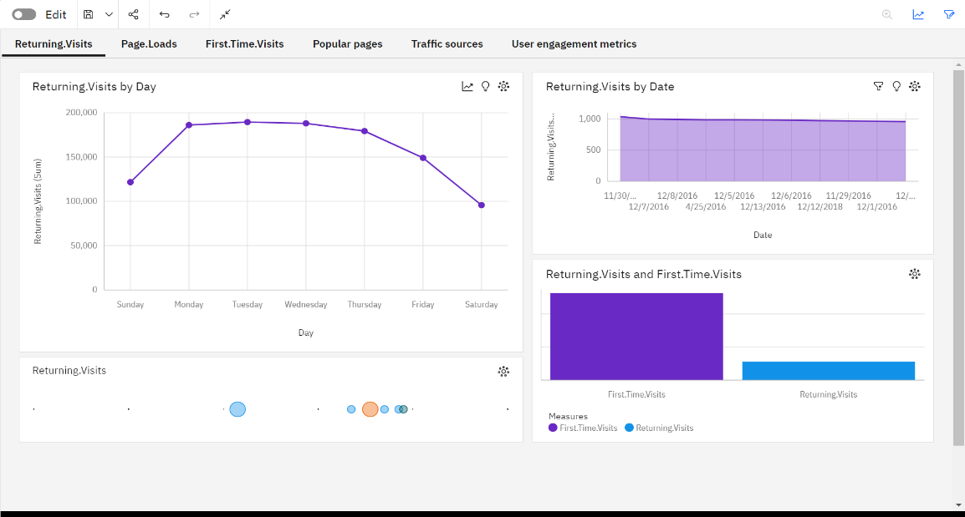

Fig 1.1

**FIG 1.****2 :** Here are the insights for Page.Loads by Day and Date, along with Unique.Visits:

**Page.Loads by Day:**

Page.Loads exhibit a significant drop on Saturdays.

A forecasted increase is expected, with Page.Loads possibly reaching 675,000 by the next Monday.

The cumulative sum of Page.Loads across all days exceeds 8.9 million.

**Page.Loads by Date:**

Page.Loads experienced a 6% drop from 2018-04-25 to 2018-11-27.

The total Page.Loads over all dates is nearly 77,000.

Page.Loads fluctuate between around 7,500 on 2016-11-30 and nearly 8,000 on 2018-04-25.

**Unique.Visits and Page.Loads:**

The current forecast suggests Unique.Visits may reach almost 481,000 by the next Monday.Both Page.Loads and Unique.Visits have a substantial volume, exceeding two thousand results each.

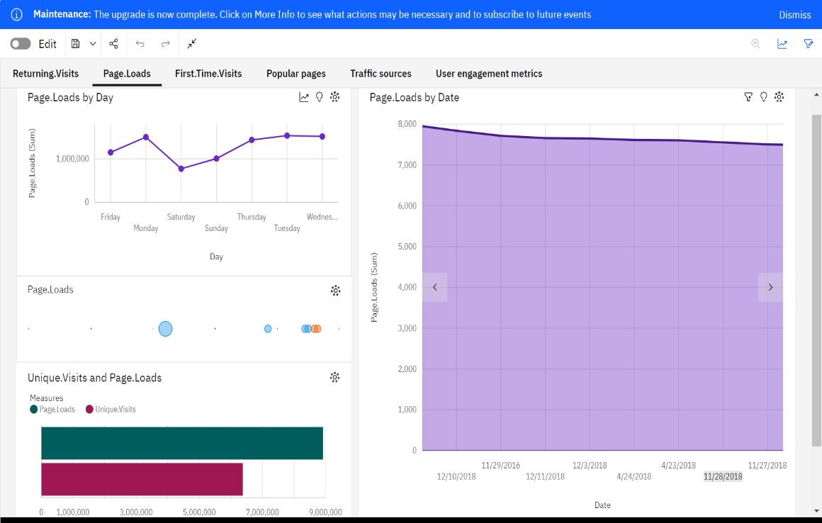

FIg 1.2

**FIG** **1.3 :** Here are the insights for First Time Visit:

**Returning.Visits and First.Time.Visits**

Based on the current forecast, First.Time.Visits are projected to exceed 395,000 by the upcoming Monday.

The combined results for First.Time.Visits total over two thousand.

Additionally, the overall results for Returning.Visits also surpass two thousand.

**First.Time.Visits by Day**

First.Time.Visits display a noticeable decrease on Saturdays.

A substantial increase in First.Time.Visits is expected, potentially reaching over 395,000 by the next Monday.

The cumulative First.Time.Visits across all days is a substantial 5.3 million.

**First.Time.Visits by Date**

There was a 4% drop in First.Time.Visits from 2018-04-25 to 2018-12-03.

The overall sum of First.Time.Visits across all dates is nearly 45,000.

First.Time.Visits fluctuate, with numbers ranging from almost 4,500 on 2016-11-30 to over 4,500 on 2018-04-25.

These insights provide a comprehensive understanding of First Time Visits, aiding in informed decision-making and data analysis.

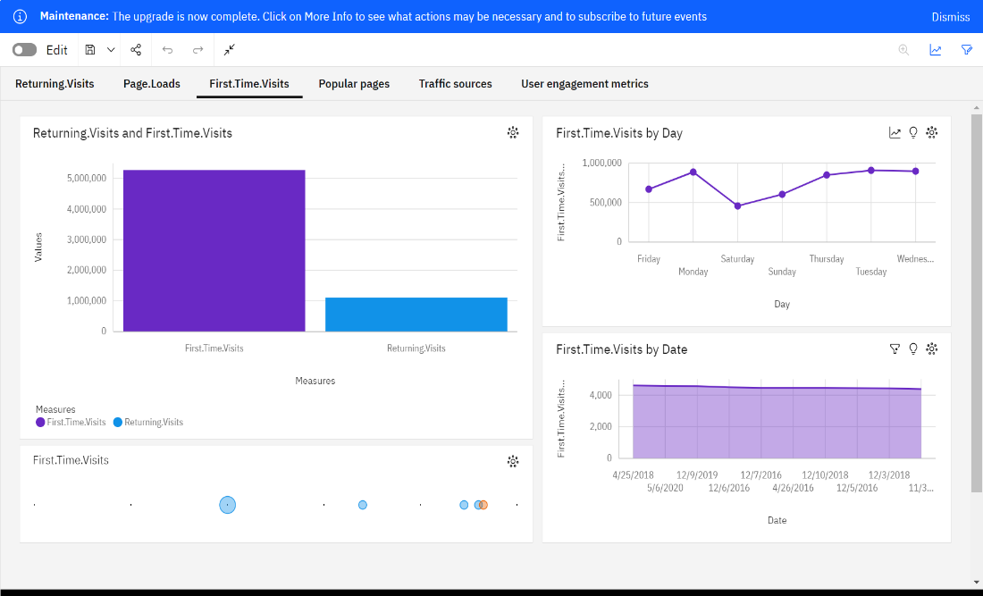

Fig 1.3

**FIG** **1.4 :** Here are the insights for Popular Page:

**First Unique.Visits by Average Page.Loads**

It is projected that by Monday+1, Unique.Visits exceeding 4,205 will surpass 3,973 by almost 1,500.

Across all values of Page.Loads, the cumulative sum of Unique.Visits reaches almost 6.4 million.

Unique.Visits exhibit a range from 667 when Page.Loads is at 1,002 to over 13,000 when Page.Loads is at 4,638.

**Unique.Visits by Page.Loads**

Unique.Visits show an unusual spike when Page.Loads reaches 7,984.

The projection indicates that Unique.Visits will exceed 3,973 by almost 1,500 by the upcoming Monday.

The strong correlation of 98% between Page.Loads and Unique.Visits highlights the significant impact of Page.Loads on Unique.Visits.

These insights offer valuable information regarding the relationship between Page.Loads and Unique.Visits, aiding in understanding and optimizing popular pages.

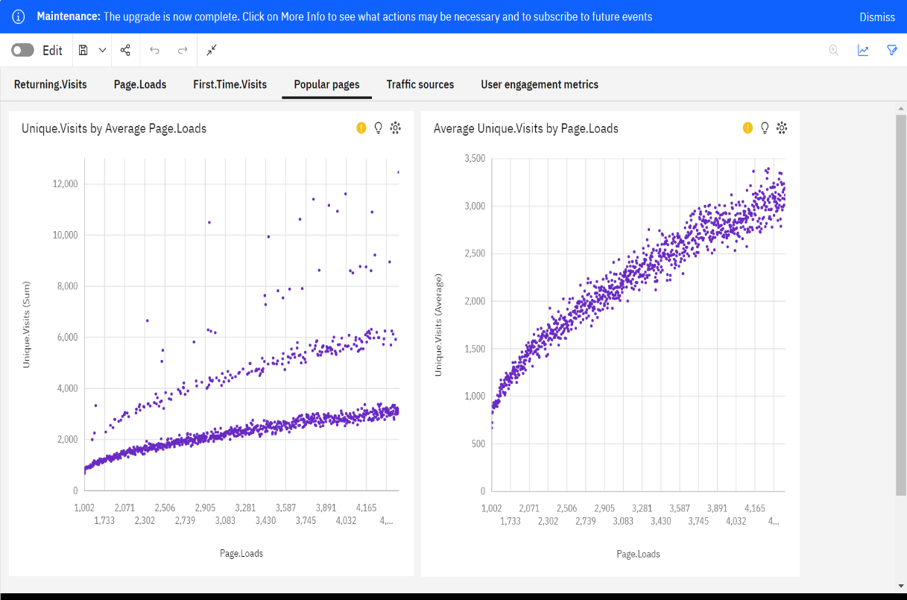

Fig 1.4

**FIG** **1.5 :** Here are the insights for Traffic sources:

**First Average Returning.Visits by Unique.Visits**

According to the current forecast, Unique.Visits are projected to reach almost 481,000 by the upcoming Monday.

The combined number of results for Returning.Visits across all Returning.Visits exceeds two thousand.

**Returning.Visits by Average Unique.Visits**

The current forecast anticipates Unique.Visits surging to over 1,500 by the next Monday.

The overall result count for Unique.Visits, considering all Returning.Visits, exceeds two thousand.

**Average First.Time.Visits by Unique.Visits**

In line with the current forecast, Unique.Visits are expected to reach almost 481,000 by the next Monday.

The total result count for First.Time.Visits, taking into account all First.Time.Visits, surpasses two thousand.

Moreover, the overall result count for Unique.Visits across all First.Time.Visits also exceeds two thousand.

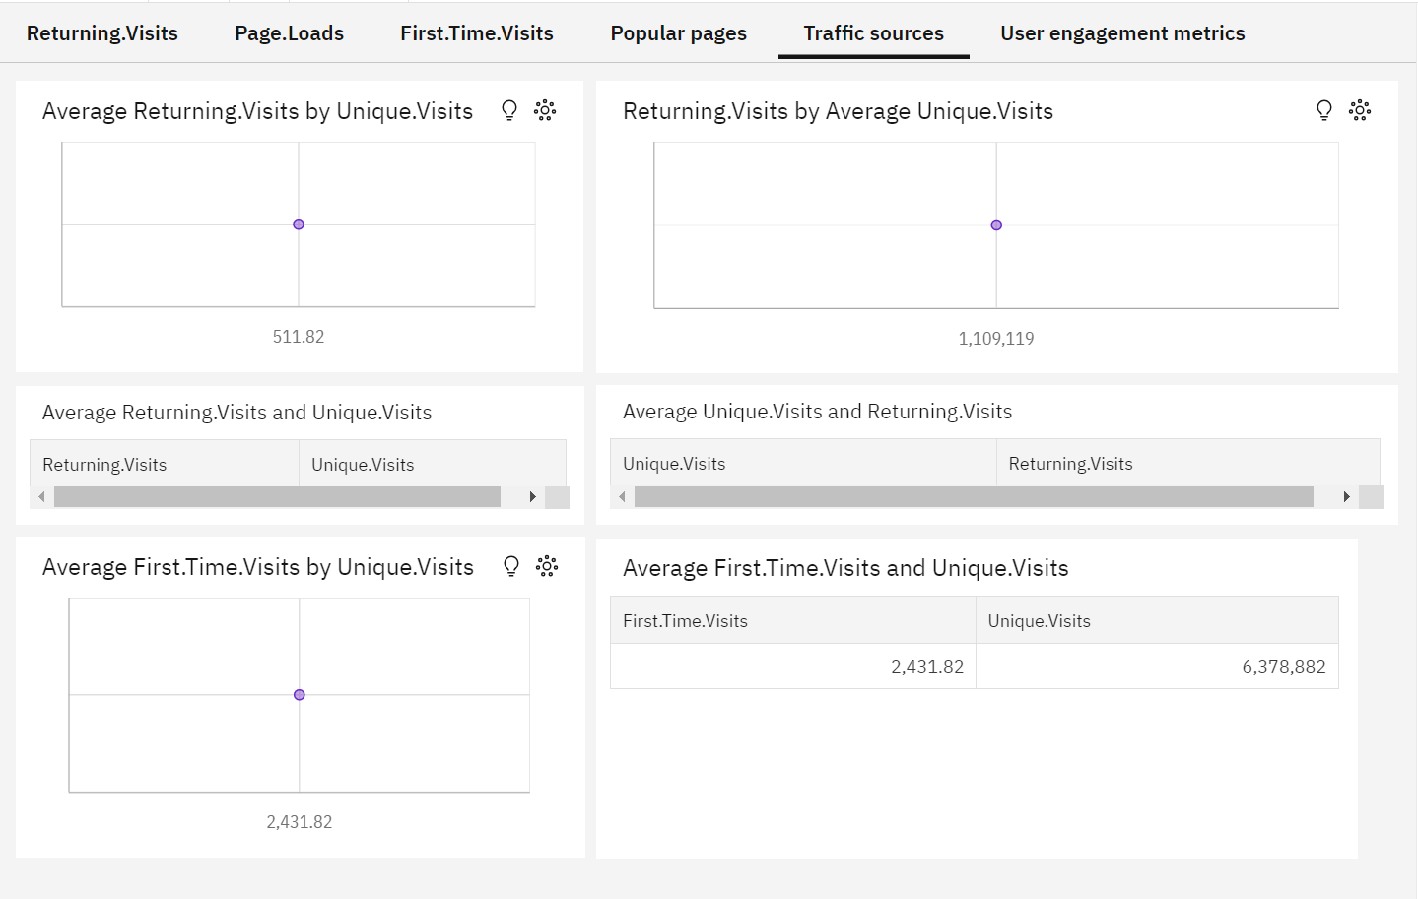

Fig 1.5

**FIG** **1.6 :** Here are the insights for User Engagement Metrics:

**Average First.Time.Visits by Unique.Visits**

The day with no specific value has the highest values for both Unique.Visits and First.Time.Visits.

**Total Unique.Visits by Average Page.Loads**

According to projections, Unique.Visits are expected to exceed 3,973 by 4,205, an increase of almost 1,500 by the next Monday.

The cumulative sum of Unique.Visits across all values of Page.Loads reaches almost 6.4 million.

Unique.Visits display a range from 667 when Page.Loads is at 1,002 to over 13,000 when Page.Loads is at 4,638.

**Average First.Time.Visits by Unique.Visits**

Similar to the first insight, the day with no specific value has the highest values for both Unique.Visits and First.Time.Visits.

**Average Returning.Visits by Unique.Visits**

Based on current forecasts, Unique.Visits may reach almost 481,000 by the next Monday.

The total number of results for Returning.Visits, considering all Returning.Visits, exceeds two thousand.

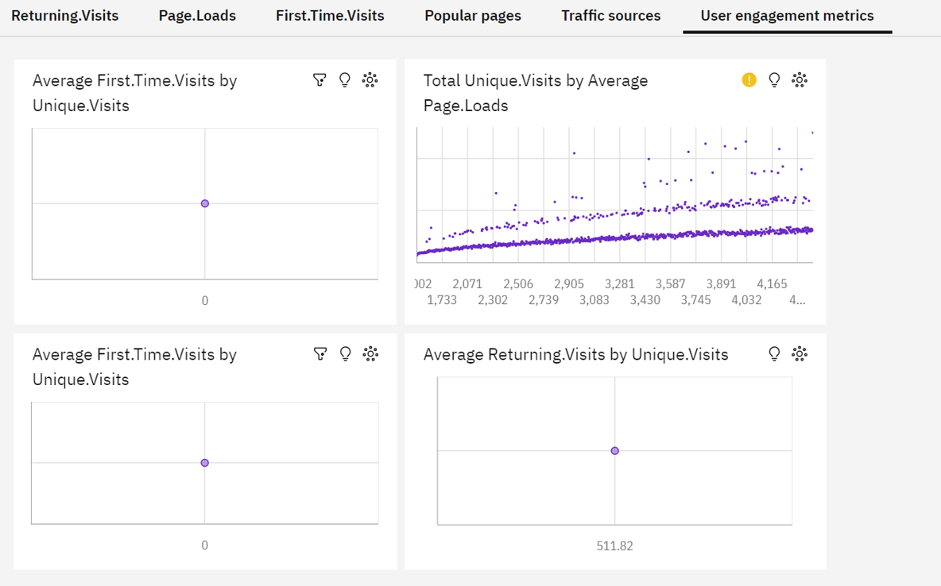

Fig 1.6

**13.HOW INSIGHTS IMPROVE USER EXPERIENCE:**

**Optimizing Content**

Understanding website traffic trends and seasonality is not only about timing but also about ensuring that users are presented with the most relevant and engaging content. By strategically scheduling content updates, promotions, and new releases during periods of high user engagement, website owners create a dynamic and exciting online environment. This approach ensures that users are more likely to encounter fresh and relevant content during their visits, which, in turn, enhances their overall experience. It's about aligning content delivery with the moments when users are most receptive, maximizing their time spent on the site and fostering user satisfaction.

**Personalization**

User segmentation through K-Means clustering offers website owners a powerful tool for personalization. By categorizing users into distinct segments based on their behavior and preferences, website owners can tailor content, recommendations, and marketing campaigns to specific user groups. Personalization significantly increases user engagement and satisfaction by delivering content and promotions that are finely tuned to individual preferences. This level of personalization creates a sense of being understood and valued, making users more likely to return to the site and engage with its offerings. The result is a more immersive and enjoyable user experience.

**Resource Allocation**

Time series forecasting and machine learning predictions enable website owners to allocate server resources with precision. This not only ensures optimal website performance but also safeguards against slowdowns or outages during traffic spikes. Such technical considerations directly impact the user experience. Users expect a website that loads quickly, responds smoothly, and doesn't interrupt their experience with technical glitches. By efficiently managing resources, website owners create a seamless and frustration-free user journey, enhancing the overall experience.

**A/B Testing and Campaign Timing**

Insights from your analysis empower website owners to conduct effective A/B testing and determine the best timing for marketing campaigns. With this knowledge, website owners can experiment with different layouts, features, or marketing approaches and evaluate their impact on user engagement. This iterative process allows website owners to fine-tune the user experience based on user preferences. A/B testing, in particular, helps in making data-driven decisions about which design or feature changes lead to better user engagement, contributing to continuous improvement.

**User Engagement Metrics Monitoring**

Continuously monitoring user engagement metrics, such as bounce rate, page views, and returning visits, serves as a vital feedback loop for website owners. These metrics allow website owners to spot issues or trends affecting the user experience. By actively identifying and addressing any decline in these metrics, website owners can take corrective actions promptly. This ongoing commitment to improving user engagement metrics leads to an evolving and responsive user experience, ensuring that users encounter a website that aligns with their evolving expectations and needs.

**User Feedback Integration**

Insights are valuable for identifying areas of concern or dissatisfaction among users. Website owners can actively collect and analyze user feedback to address pain points and enhance the overall user experience. Feedback integration is a proactive approach to addressing user concerns and expectations, creating a sense of user-centricity. It enables website owners to iteratively refine their offerings and demonstrates a commitment to continuously improving the user experience. This not only improves user satisfaction but also fosters user loyalty and advocacy.

**14.CONCLUSION:**

In conclusion, our website traffic analysis project represents a holistic approach to understanding user behavior and enhancing the user experience. By integrating data analysis, time series forecasting, machine learning, and data visualization, we have provided website owners with actionable insights. These insights empower website owners to make data-driven decisions, optimize their platforms, and ultimately create a more engaging and user-centric digital environment. The journey from problem identification to technology integration has been an exciting and informative one, and we believe it will significantly benefit website owners in their quest to enhance user experience.